# **Psychological Study on Identity Fusion in the Optimism Ecosystem**

*Note: This post is in reference to blockchain community research supported by a grant under the Optimism Academic Grants Round (2023). It provides an overview of the preliminary insights from this study. The content presented in this post is being developed into a forthcoming, academic publication.*

ABSTRACT

A noteworthy characteristic of crypto spaces is their powerful communities of supporters, who typically gather on interactive online platforms such as Discord, using shared social codes as an expression of their strong sense of collective identity with a particular crypto community. Despite its pseudonymous nature, crypto has become a means for developing relational ties that seem remarkably robust. What has been overlooked so far, however, are the mechanisms through which strong social bonds are formed in decentralised, pseudonymous environments with minimal in-person interaction, such as crypto. Psychological theories of trust and decision-making suggest an important role of social identity and social norms, due to a fundamental human need to find a sense of belonging.

Using a mixed-method approach, and Optimism as a distinct case study, this study examines the user-network relationships in crypto communities through the lens of identity fusion, i.e. the tendency for individuals to merge their sense-of-self with that of a social group to which they belong. Preliminary results indicate an interplay of interpersonal and structural mechanisms for developing identity fusion in pseudonymous spaces. Whereas the interpersonal factors primarily include perceived group agency and perceived similarity to others in the group, the structural mechanisms refer to an ‘optimal balance’ between group size, growth, and authentic community feeling that we label the “goldilocks zone” of identity fusion in crypto communities.

OVERVIEW/TLDR

This is an interim report, shedding light on the underlying mechanisms that drive “identity fusion” and group cohesion in the Optimism ecosystem.

* Study aim: Exploring layers of identities and group cohesion on Optimism, and across protocols within the Optimism ecosystem.
* Main question: What are the underlying mechanisms that drive people’s *fusion* with Optimism, i.e., bring users closer to the Optimism network?
* Relevance and impact: Identity fusion leads to enduring group commitment and attachment to the Optimism network.
* Preliminary insights: Interplay between (inter-)personal and structural mechanisms shaping identity fusion

This study taps into the highly relevant question of how individuals develop trust and reciprocity within and across group boundaries in rapidly-growing blockchain ecosystems. It examines the social mechanisms that users leverage to build trust and develop a deep connection with Optimism. In order to attract and retain highly committed members – and consequently, keep liquidity on chain – strong relational ties amongst users and the more abstract network itself are needed.

SUMMARY OF PRELIMINARY FINDINGS

**Milestones 1 & 4: Perceived Personality and Potential Drivers for Identity Fusion**

Methodological steps: Exploratory and in-depth interviews with members of Optimism and other protocols within the Optimism ecosystem; exploration of perceived personality of Optimism community and insights into potential drivers for identity fusion or non-fusion.

Key results:

The key results point to several (inter-)personal and structural mechanisms, shaping identity fusion between users and protocols.

|  |  |
| --- | --- |
| (Inter-)personal mechanisms: | Structural mechanisms: |
|  |  |
| * Perceived personality * Team-community relations * Perceived group agency * Perceived similarity to others | Optimal balance between:   * Group size, growth, and authentic community feeling * Serious building vs. ‘chit-chatter’ |

Detailed results:

* **Recognisable lead developers:** Lead developers’ publicity and reputation plays a key role in attracting people to protocols. At Optimism, it’s more about the ethos, less about Optimism’s core developers. The spirit „impact over profit“ is partly what brings people to Optimism and what keeps them there.
* **Role of the team:** For smaller protocols, team/recognisable leaders are very important. Participants especially point out professionalism and approachability of developers leading to a solid ground for trust and community. However, this is very top-down/not decentralised. Optimism has the opposite problem of not having clear leadership.
* **Perceived personality:** Optimism is generally perceived as trustworthy, rooted in a vision worth supporting, and having a promising future even through market downturns due to its size, governance, and decentralisation. Optimism is not seen as primarily profit-oriented or hyped, nor tied to any specific named leaders or developers. However, many find it hard to pin down what exactly the special features of the Optimism community are compared to some projects with more social communities or more memorable branding.
* **Size of the community:** Participants seem to desire a specific community size. It should ideally be large enough to foster lively interactions, regular updates, channels for different topics, room for both technical and everyday conversations, and opportunities to meet and get to know developers, moderators and other users. While some of the smaller protocols are perceived as too small at the moment, Optimism is seen as having a good size, but structurally confusing. Participants reported struggles with navigating the Discord channels, understanding the ecosystem mechanisms, and community members/roles.
* **Communication features on Discord:** People report the communication at Optimism as welcoming, serious/formal, transparent, but not very social; a “community vibe” is missing. There is a strong focus on ethos, which seems to really resonate with users. Apart from Optimism’s ethos, technology and governance take centre stage.
* **Interplay (inter-)personal & structural mechanisms:** There seems to be a balance to strike between seemingly opposing factors, such as, seriousness and hype associated with a protocol. The results indicate a trade-off between growth and authentic community feeling, particularly at Optimism where social features or a recognisable “community vibe” seems to be missing.
* **Promising outlook:** An outlook for future growth is crucial for retaining people in a community. The future growth potential represents a decisive driver for people’s commitment to Optimism.

**Milestone 2: Survey**

Methodological steps: Online survey, including a total of 30 questions, shared on various channels, e.g., X, Farcaster, dedicated “community study” channel in the Optimism Discord, and Optimism forum (see <https://gov.optimism.io/t/last-call-for-study-participants-complete-survey-and-win-5x-100-usdc/8147>); quantitative correlation and regression analysis.

Sample:

The survey was filled out by 110 participants, split into users who primarily engage with Optimism, Beethoven X, OATH, and Balancer. Users of Velodrome were excluded due to too low participant numbers.

Demographics:

92% of participants are male, with the majority of them being regular users (72%) (as opposed to team members, moderators, or lead devs), and between 31 and 40 years old (39%). Most of the participants have an IT/CS (computer science) background. 46% have been active members of their favourite community, i.e., Optimism, Beethoven X, OATH or Balancer, for 2 or more years. Whereas most (63%) report to be mainly engaging with team members, a considerable number of people (17%) were not able to identify who they are talking to in their community (see figures 1-5).

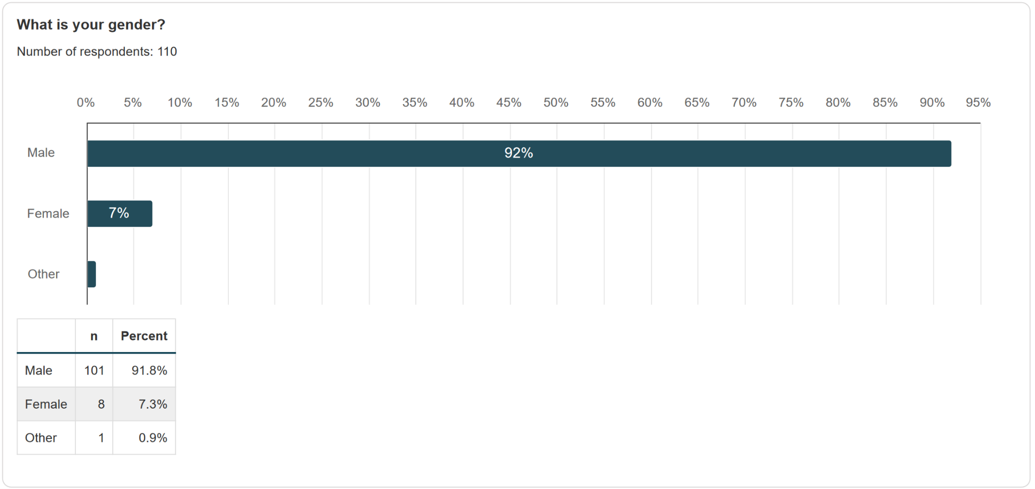

Figure 1: Distribution of gender of participants.

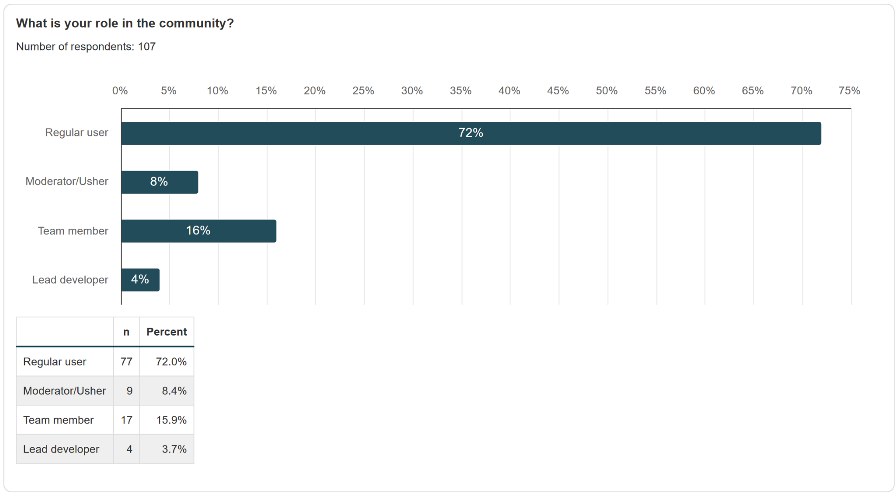

Figure 2: Participants’ role in the community.

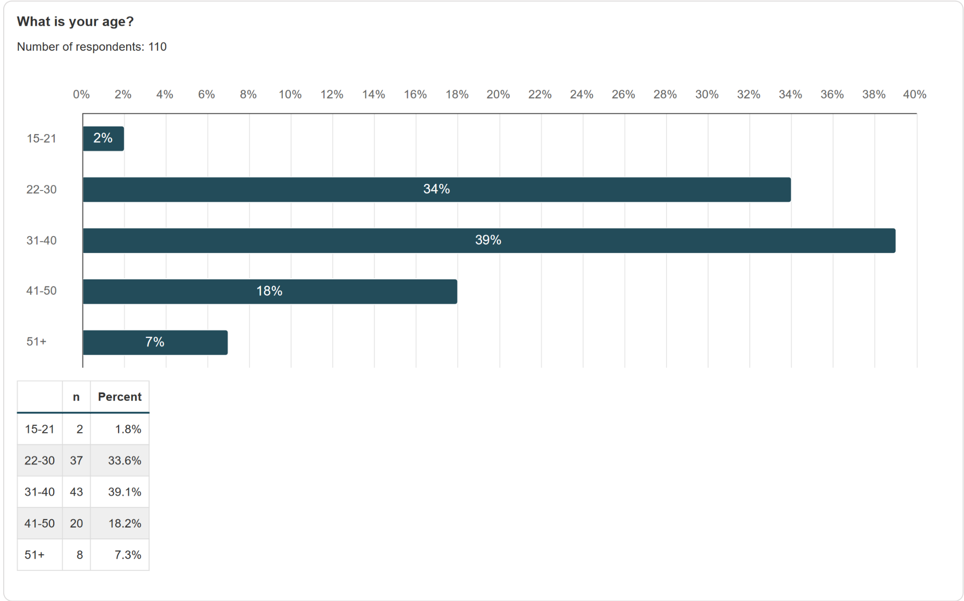

Figure 3: Distribution of age of participants.

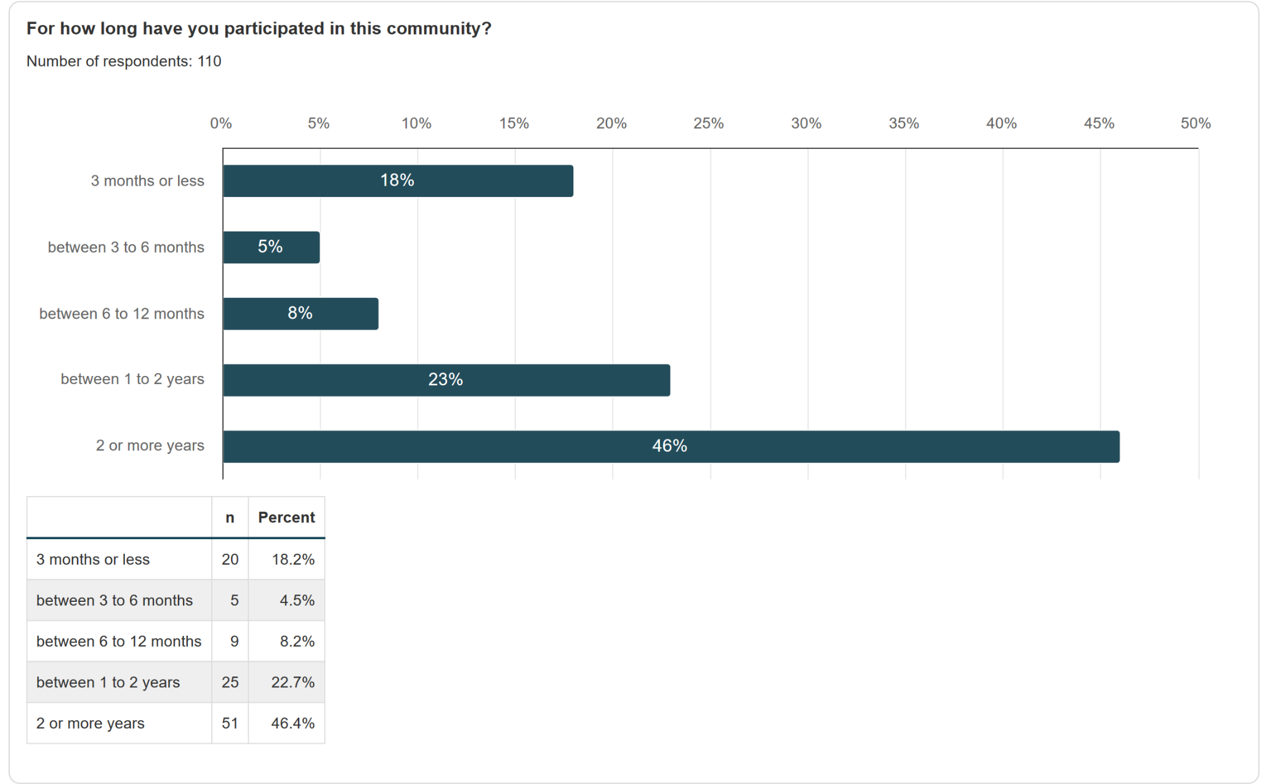

Figure 4: Participants’ years of engagement in the community.

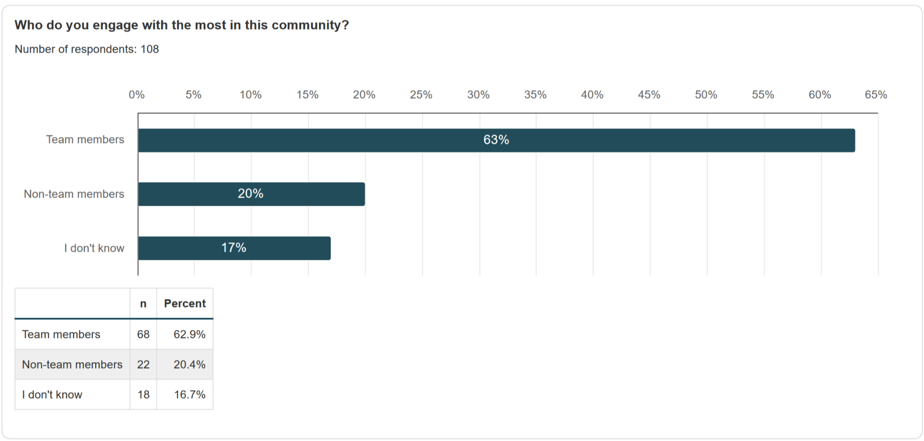

Figure 5: Participants’ reference person within the community.

Summary of preliminary insights into drivers of identity fusion:

The vast survey results are currently in the process of being analysed, but first impressions point at further illuminating insights regarding what motivates users to stay with a protocol and its community or leave.

The decisive (inter-)personal factors include ‘agentic personal self’, ‘social features’, and a ‘positive outlook’.

**Agentic personal self:** It is important for people to feel valued and experience a sense of ownership (have impact) within the community. This is captured by statements like ‘my presence matters to the community’.

**Social features:** There seems to be a desire for deeper social relationships/friendships within the community, especially on Optimism. Social features are captured by statements like:

* I have made meaningful friendships
* I have fun in the community
* I would hang out with these people, even if I didn’t make any profit

**Positive outlook:** A positive outlook reflects in how serious people think the protocol is about DeFi and advancing the space (long-term interest). A positive outlook is evaluated by statements like:

* I think this community will still exist in 2 years
* I think we’re building the tech of the future
* I’ve considered leaving this project (negative)

**Size and content:** Finally, critical structural factors include a balance between ‘actual size & content’ vs. ‘ideal size and content’ (see Figure 6).

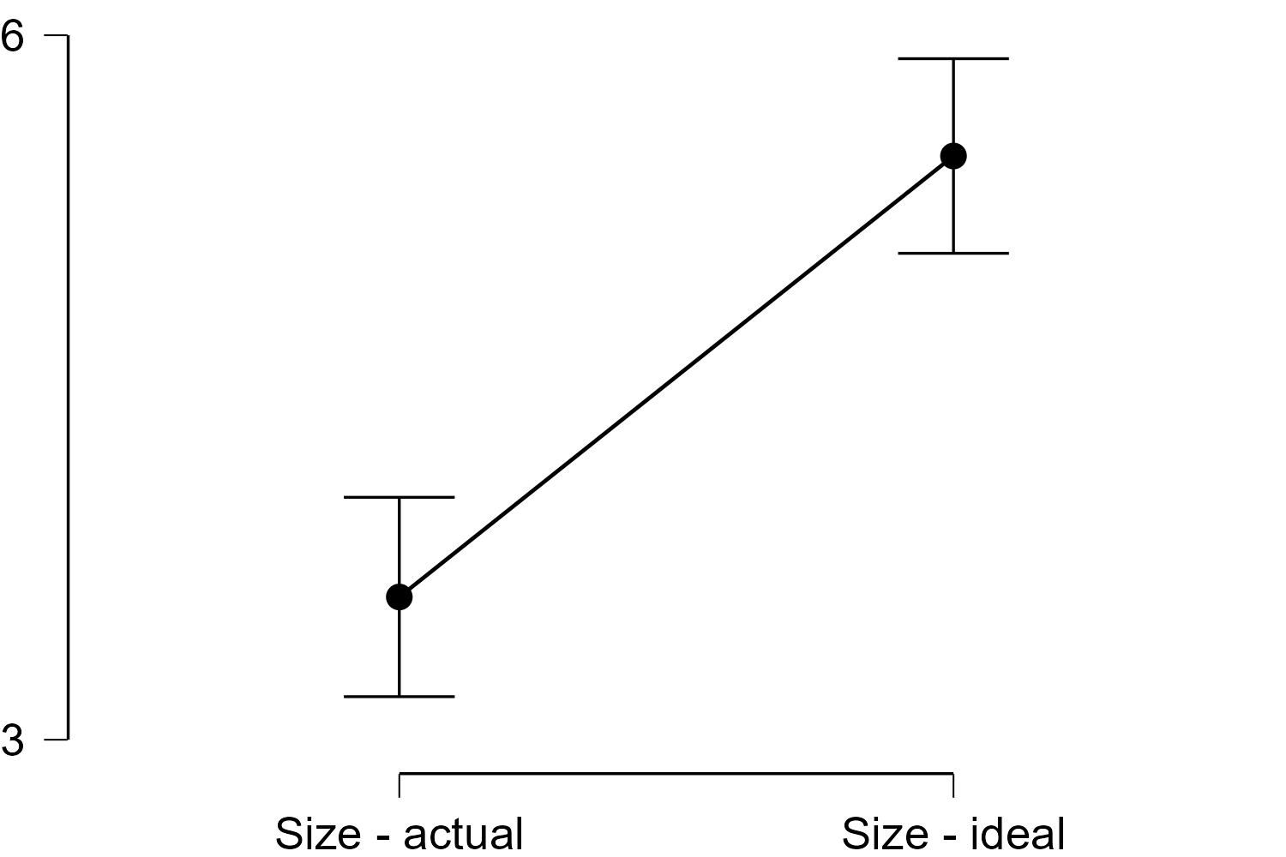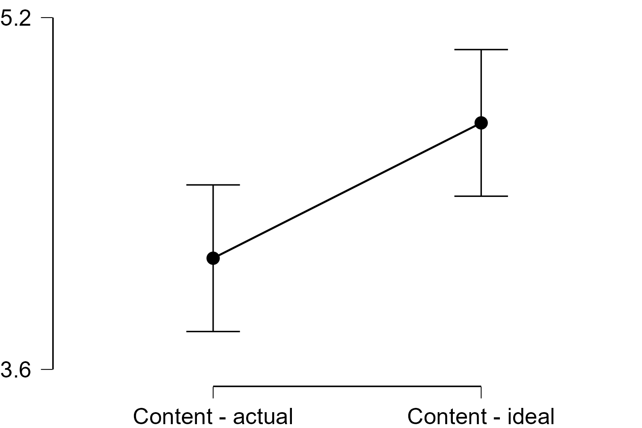

Figure 6: Actual vs. ideal size and content.

Whereas the size seems to be ideal at Optimism, there seems to be a mismatch between the current versus desired content posted on Optimism.

After a full statistical analysis, results will be integrated with the key results from the qualitative methods (milestones 1, 2 and 4) to offer a holistic view on users’ identity fusion.

**Milestone 3: Discord analysis**

Methodological steps: Manual screening and content analysis of language use in the “general chat” of the Optimism Discord (non self-reported behaviour); identification of linguistic proxies for identity fusion and other relevant factors for identity fusion. We mainly analysed how people communicate, what people talk about, and which people (in terms of role) communicate.

Formal language use:

* “Sober” and rather formal, mainly focussed on technicality & governance
* Not hyping or flashy
* Neutral language; no price discussions

Wide range of content, little character:

* Limited diversity of posts: people mainly post if they have questions, need support or guidance, or want to promote something
* High frequency of posts; high number of active posters
* Number of “unique” (recurring) posters: mainly the team and core contributors posting (e.g., ambassadors, nerds, wanna-be-nerds)

Imbalance between ‘serious building’ and ‘social chatter’:

* A lot of interaction, but mainly around technicality of Optimism and governance-related questions that are transferred to gov-related channels
* A lot of chatter, not much deeper conversation

**Milestone 5: Reporting and Preliminary Suggestions for Optimism**

**Strengthening of social bonding factors:**

According to our observations, Optimism strikes a good balance of promoting a vision while avoiding hype, and has advantages over smaller protocols due to its size and stability, which leads to trust and positive future outlooks from users. At the same time, however, social bonding factors at work in other protocols are missing. Participants describe having fewer meaningful interactions with other users or community leaders, and perceive the community as engaged but formal.

Strengthening Optimism’s social capital could help to build community-relevant value. Social capital refers to the advantages that people enjoy from their relationships within the wider networks that promote the exchange of information and knowledge and benefit the whole community. Including playful tools that allow managing tasks and assigning custom roles may fit that purpose. Effective communication, reputation systems, and distinct roles will help build engagement, increase the internal flow of information and boost the quality of ideas circulating in the community. Ideally, ideas will be communicated faster and with higher credibility. Implementing new features to foster informal exchanges for those users who wish to partake in them could further increase how bonded users feel with Optimism.

Finally, implementing community-centric features including specific working groups, “happy hours” or informal hangout spaces in collaboration with other protocols could additionally foster bridging knowledge gaps and encouraging members of different groups to tap into new sources of information, knowledge and insights.

**Unique features and authentic community feeling:**

Optimism’s ethos is clear and recognisable, but Optimism as a brand lacks distinct community traits. This might partly be due to Optimism’s strong focus on technology and governance. To stimulate the development of authentic and unique community features, meaningful social interactions are essential. Launching impactful initiatives that reward content creation, storytelling, bug reporting, and governance contributions will help to shape unique community traits. This can include offering exclusive access to new features, or recognition within the community.

**Clearer guidance needed:**

Connect first time users with Optimism delegates or other established community members to help them navigate the complex ecosystem. Establishing a board of recognisable and knowledgeable members, as well as introducing beginner’s events, could further assist in supporting new users. Many users feel a bit overwhelmed with the size and confusing Discord. As there is an absence of clear identifiable leaders, other community members such as moderators or delegates need to fill this gap; they don’t need to be developers, but recognisable & knowledgeable members that users trust.

**Outlook Final Report:**

The final report/presentation will provide insights into the following factors:

* Layers of identity: insights into the extent of people’s identity fusion with Optimism.
* Explanations of how fusion may (or may not) work on Optimism.
* Targeted recommendations to strengthen identity fusion and group cohesion on Optimism.

The final report will be informed not only by academic insights and learnings from this study, it will also be developed into a forthcoming, academic publication.

As always, stay Optimistic!